.NET Boggle User Guide

**Objective of Boggle**

Form words you can see within the time limit.  
The longer the word, the more points you get!

**Getting Started**

Begin by pressing *Play*.

The game will randomly place 16 letters on to the game grid. When the timer starts, you have 3 minutes (configurable) to enter in as many words as you can find.

**Rules**

* Words must be three characters or longer
* Letters must be adjacent to the previous letter
* Tiles cannot be reused in a word
* Words can only be submitted once

**Scoring and Winning**

The longer the word, the more points it is worth! The table below explains the scoring.

|  |  |
| --- | --- |
| Word Length | Score Value |
| 3 – 4 | 1 |
| 5 | 2 |
| 6 | 3 |
| 7 | 5 |
| 8+ | 11 |

**Tips**

Plurals count as different words

The "Qu" tile counts as two letters

**The Game Interface**

Boggle Gameboard

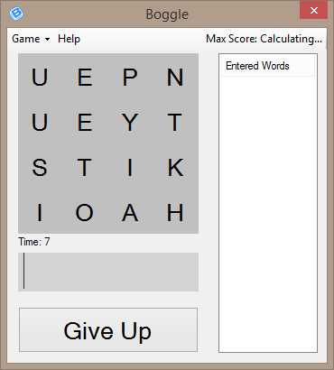

Remaining Time

Play / Give Up Button

Word List

Input Box  
(type here!)